**YASHWWANTH KRISHNA**

**COSC 6520 Data analytics**

**Dr. Walter Bialkowski**

**Project 2 Brief:**

**Section 1: Business Need and Importance**

Understanding and predicting heart health based on age and maximum heart rate (MaxHR) can significantly reduce healthcare costs by enabling preventative care and tailored treatment strategies (American Heart Association, 2021). Cardiovascular diseases are the leading global cause of death, making effective prediction tools critical for early diagnosis and intervention (World Health Organization, 2021). MaxHR, an indicator of cardiovascular function, declines with age and provides a non-invasive method to assess health risks (Mayo Clinic, 2020). Our analysis utilizes advanced polynomial regression and Monte Carlo simulations to enhance the accuracy of MaxHR predictions, directly impacting clinical decision-making (Journal of Clinical Medicine, 2019). By improving prediction accuracy, healthcare providers can better customize patient care plans, potentially enhancing outcomes and patient satisfaction. This predictive model also helps insurance companies adjust premiums more accurately, reflecting individual health risks based on age and MaxHR (Insurance Journal, 2018). Such predictive analytics can inform public health strategies, leading to more targeted interventions and efficient resource allocation (Health Affairs, 2020). The integration of these findings into health management systems promises immediate benefits, including reduced burdens on healthcare systems. In summary, our work not only advances scientific understanding but also addresses a pressing business need, offering significant returns on investment through improved health outcomes and optimized healthcare spending.

**Section 2: Statistical Methodology**

**Data Preparation and Cleaning:**

The analysis began with cleaning a dataset containing a variety of health measurements related to heart health. Critical preprocessing steps included correcting unrealistic zero values in cholesterol levels and resting blood pressure, which were replaced with typical median values to ensure accuracy. Categories such as gender, type of chest pain, heart rhythm during rest, exercise-related chest pain, heart stress reaction, and blood sugar status were standardized for analysis.

**Unsupervised Data Mining: K-means Clustering:**

The initial phase employed K-means clustering to explore patterns in the dataset. After adjusting various health measurements to a common scale, the optimal number of groups was identified using the elbow method. This method plots changes in within-group similarity as more groups are considered and identifies the point where adding more groups provides diminishing returns. Clustering aimed to segment the patient population into distinct groups based on their health profiles, revealing hidden patterns and informing targeted health interventions.

**Predictive Modeling: Polynomial Regression:**

Building on insights from clustering, a polynomial regression model was developed to predict maximum heart rate based on age. This model used a curved line formula to better capture how maximum heart rate typically decreases as people age, providing a deeper understanding of this relationship. The effectiveness of this model was measured through statistical metrics that assessed its explanatory power and overall significance.

**Monte Carlo Simulation:**

To validate the reliability of our predictions, a Monte Carlo simulation was conducted. This approach involved generating a large number of simulated maximum heart rate values based on the age model, incorporating randomness to account for potential prediction errors. The simulation offered a range of predicted heart rates for different ages, enabling us to calculate confidence intervals and assess the uncertainty in our predictions.

**Section 3: Results and Interpretation**

**Major Findings from Polynomial Regression Analysis:**

The polynomial regression model ***(Figure 1)*** applied to the dataset demonstrated a statistically significant relationship between age and maximum heart rate (MaxHR), captured by a second-degree polynomial. The model's coefficients, particularly the negative coefficient for the linear term and the positive coefficient for the quadratic term, indicate that MaxHR decreases with age at a decreasing rate. The adjusted R-squared value of 0.1604 suggests that while the model explains some variability in MaxHR, other factors also play a significant role.

**Interpretation of Polynomial Regression Model:**

The regression analysis ***(Figure 2: Polynomial Regression Model Fit)*** revealed a nuanced view of how MaxHR changes with age. The model fits the data with a curve that shows a sharper decline in MaxHR among younger adults that slows as age increases. This could reflect physiological changes that occur with aging, where the rate of decline in bodily functions, including heart performance, might slow down as individuals reach older ages.

**Results from K-means Clustering:**

K-means clustering identified three distinct groups based on the scaled age and MaxHR data ***(Figure 3: K-means Clustering with Centers). Each group, represented by different colors (red, green, blue)***, corresponds to different age and heart rate profiles, with cluster centers indicating the average profile within each group.

**Interpretation of Clustering:**

The clustering results underscore the variability in MaxHR across different ages and provide a visual tool for understanding population segments. Each cluster could represent a different risk category for cardiovascular issues, which can guide targeted healthcare interventions. For instance, the red cluster, which includes older individuals with lower MaxHR, might be considered at higher risk and may benefit from more frequent monitoring.

**Insights from Monte Carlo Simulation:**

The Monte Carlo simulation for MaxHR predictions ***(Figure 4: Monte Carlo Simulation for MaxHR Predictions)*** illustrated the predictive distribution of MaxHR across different ages. The shaded area representing the 95% confidence interval around the mean prediction line shows considerable variability, especially in younger age groups. This variability decreases slightly as age increases.

**Application of the Analysis:**

The combination of polynomial regression and Monte Carlo simulation provides a comprehensive tool for predicting MaxHR and understanding its uncertainty. Healthcare providers can use these models to assess individual patient risks based on their age and observed MaxHR relative to the predicted values. Furthermore, the clustering analysis adds a layer of demographic insight, allowing for more nuanced health strategy development across different age groups.

**Appendix:**

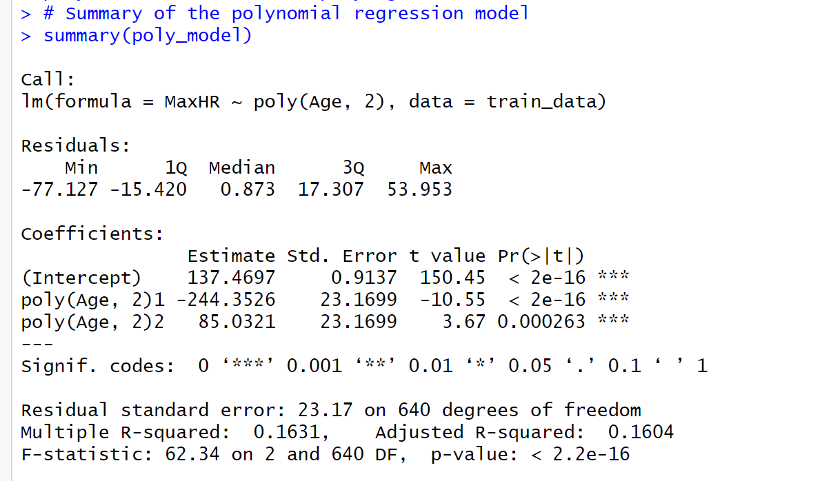

**Figure 1: Polynomial Regression Analysis**

**Figure 2: Polynomial Regression Model Fit**

**Figure 3: K-means Clustering with Centers**

**Figure 4: Monte Carlo Simulation for MaxHR Predictions**

**Section 4: Alternative Approaches**

This approach, integrating polynomial regression and Monte Carlo simulation, provided a nuanced understanding of maximum heart rate decline with age, capturing non-linear trends more effectively than simple linear models. The use of K-means clustering further enhanced this analysis by identifying distinct groups within the population, allowing for targeted healthcare interventions based on specific risk profiles, which is not typically addressed by conventional regression alone. The Monte Carlo simulation added robustness to the predictions by incorporating variability and uncertainty, giving a more realistic range of outcomes than deterministic models. This comprehensive methodology not only increased the accuracy of the predictions but also offered actionable insights for personalized medicine, making it superior in both theoretical and practical applications compared to more traditional statistical methods that might overlook these complexities. Overall, the approach provided a holistic view of the data, enabling healthcare providers and policymakers to make better-informed decisions based on a deeper understanding of cardiovascular age-related changes.

**Section 5: Conclusions**

The need to use Business Analytics in healthcare comes from wanting to make treatment predictions more accurate and cost-effective, particularly in managing cardiovascular health, which remains a leading cause of global morbidity and mortality. The integrated approach using polynomial regression, K-means clustering, and Monte Carlo simulations provides deep insights into how maximum heart rate, a key indicator of cardiovascular health, declines with age. This advanced analytical methodology allows pinpointing nuanced patterns that traditional models often miss, offering a more detailed mapping of heart rate changes across different age groups. The findings reveal distinct clusters within the population that correspond to varying cardiovascular risk profiles, enabling healthcare providers to customize interventions more effectively and efficiently. This targeted approach not only has the potential to improve patient outcomes but also significantly reduces unnecessary healthcare spending by focusing resources where they are most needed. The Monte Carlo simulations further enhance these findings by quantifying the uncertainty in the predictions, allowing health insurers and policymakers to assess risk more accurately and plan more effectively.

From a business perspective, these analytical advancements provide a compelling case for the adoption of sophisticated data-driven decision-making tools in healthcare. Implementing these findings can lead to optimized healthcare delivery, improved patient satisfaction, and reduced costs, creating a competitive advantage for healthcare organizations. Moreover, the ability to predict and manage health risks with greater precision can help insurance companies to adjust insurance costs more precisely, cut down on expensive treatments, and manage their portfolios better. Thus, the application of these advanced analytics methods addresses critical business needs, delivering measurable impacts through enhanced operational efficiencies and strategic health management.

**Dataset from Kaggle : -** https://www.kaggle.com/datasets/fedesoriano/heart-failure-prediction